Introduction to Linux, Basic Commands, File Management, and User Management

# Section 1: Linux Basics

1. What is Linux, and how does it differ from other operating systems like Windows and macOS?

*it is an open source system that resembles UNIX and is characterized by being skilled and available for use and modification.

*windows and macos closed system source code is not available to users,easy to use,but with retrictions on customization and source code.

1. Name three popular Linux distributions and briefly describe one of them.

* Kali Linux, Dabian and Ubuntu , The Dabian it is considered one of the systems for safety.

1. What is the root directory in Linux, and what is its significance?

* the main folder contains all the files and folders.

1. Explain the difference between an absolute path and a relative path in Linux.

* The absolute path is the full title of the file or folder,the root starts,while the relative path is a partial address starting from the current users location.

1. What command would you use to update the package list on a Debian-based system?

* sudo apt update .

# Section 2: Basic Commands and Navigation

1. Write the command to display the current working directory.

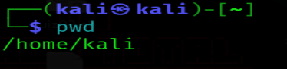

1. How do you change to the `/etc` directory from your current location? 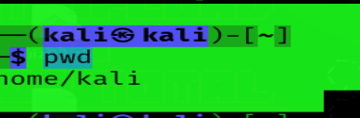
2. List the contents of the `/home` directory, including hidden files, in a detailed list format. 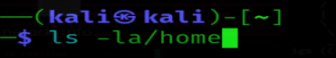
3. Explain the purpose of the `ls -l` command and what information it provides.

* Displays the contents and information of the directory in detail.

1. What command can be used to return to your home directory from any location in the file system?

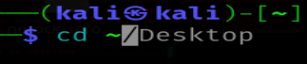

# Section 3: File Management

1. Write the command to create an empty file named `testfile.txt`. 
2. How do you create a directory named `testdir`?



1. Write the command to copy `testfile.txt` to `backup_testfile.txt`.



1. What command would you use to move (rename) `testfile.txt` to `newfile.txt`?



1. Write the command to remove the directory `testdir` and its contents.



# Section 4: User and Group Management

1. How can you list all existing users on the system?

* 

1. Write the command to create a new user with the username `newuser`.

* 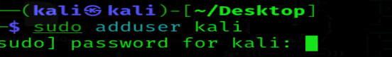

1. How do you create a new group named `newgroup`?

* 

1. Write the command to add the user `newuser` to the group `newgroup`.

* 

1. What command would you use to change the password for the user `newuser`?

* 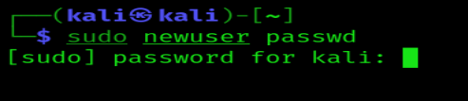

# Section 5: Practical Application

1. Describe the steps you would take to install a Linux distribution on a virtual machine.

* Download and install VirtualBox

* Create a new virtual machine

* Download the ISO file for Linux distribution

* Configure the virtual machine

* Start installation

1. If you are in the `/home/user` directory, what command would you use to navigate to `/var/log`?

* 

1. How do you display the contents of the current directory in a human-readable format?

* 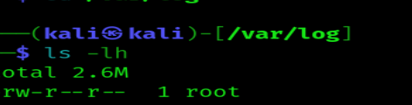

1. Explain what the following command does: `cp -r /home/user/docs /home/user/docs_backup`.

* Copies the contents of the docs directory to a new directory named docs-backup

1. What is the difference between the `rm` and `rm -r` commands?

*rm / Used to delete a file or files only.

*rm-r / Used to delete a directory (folder) and its contents

1. Explain the significance of the `/etc` directory in Linux.

* It is a central repository for critical system configuration files. Plays a vital role in managing the Linux system by storing network configuration files, authentication and authorization files for users.